Assembling the fault model
1. Cut out the two seismic profiles.
2. There is normal fault marked on each with a solid black line, mark the upthrow and downthrow sides with arrows:

On line S1-11 the downthrow is towards the _______ direction.
On line S2-11 the downthrow is towards the _______ direction.

3. On line S1-11 cut along the dashed line at CMP 60, and cut the fault from the bottom to time 0 msec.
4. Do the same on line S2-11: cut along the dashed line at CMP 60, and cut the fault from the bottom to time 0 msec.
5. Fit the two profiles together to make a 3D model.
6. Cut out the fault plane below and insert it into the model along the fault cuts.
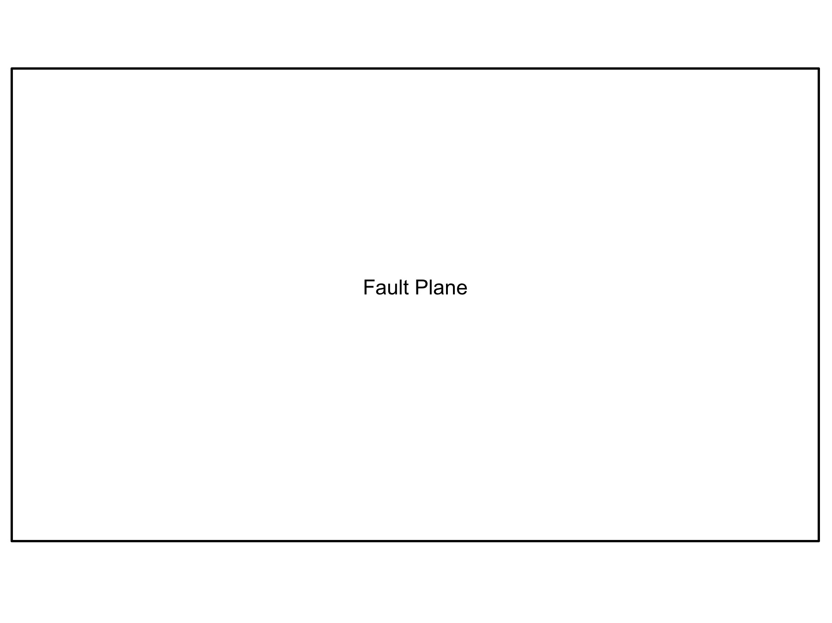

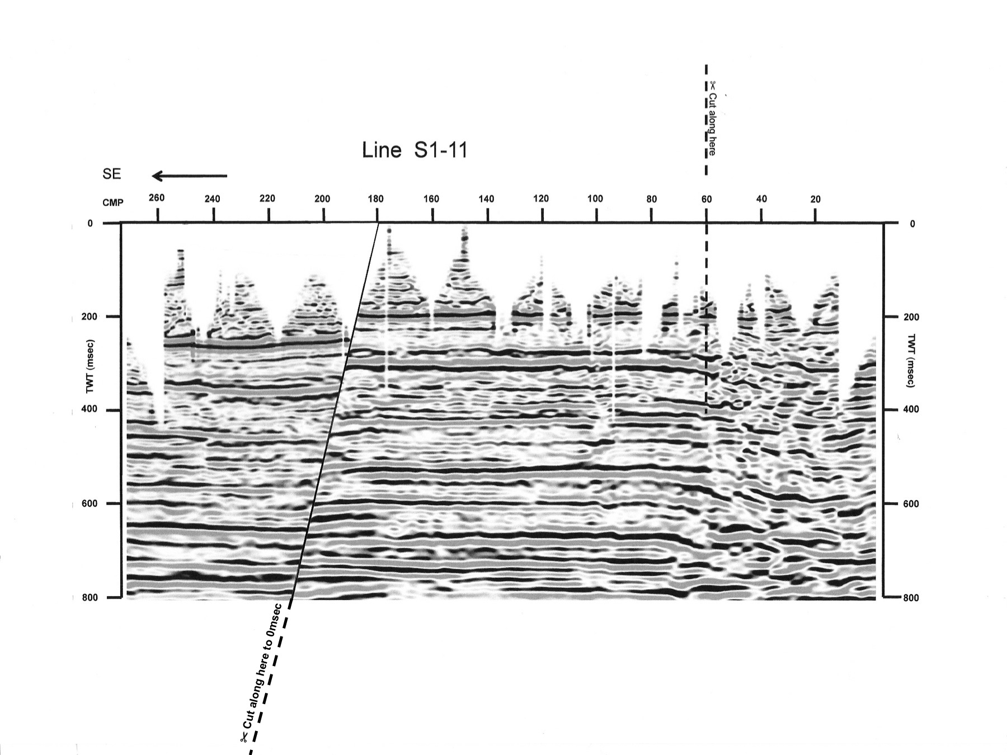

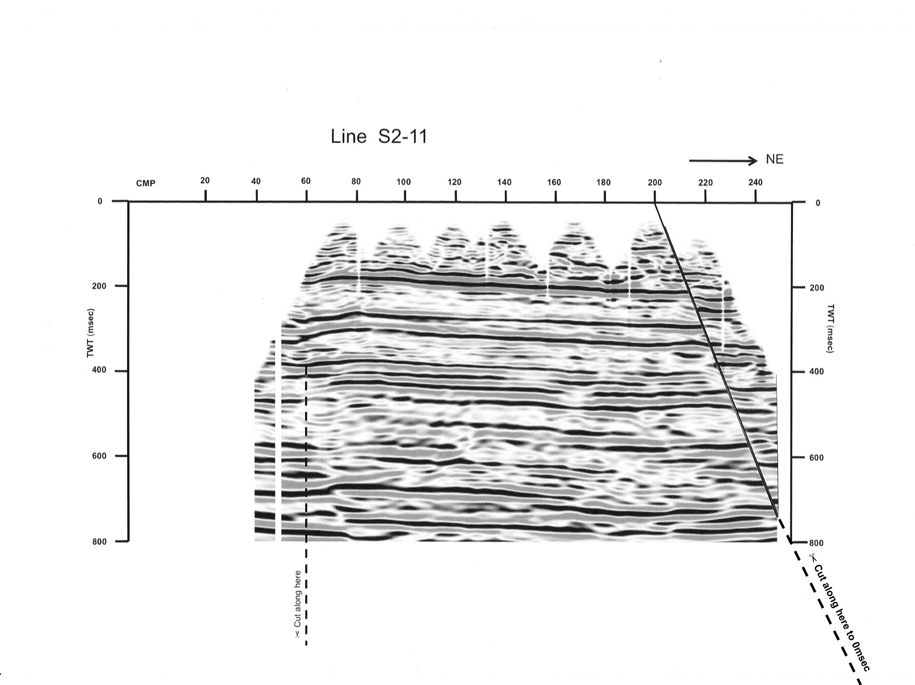
Seismic profiles for fault model

