Name ___________________ Date________
Fault picking exercise
There are two horizons to interpret and several faults to pick on this seismic profile.
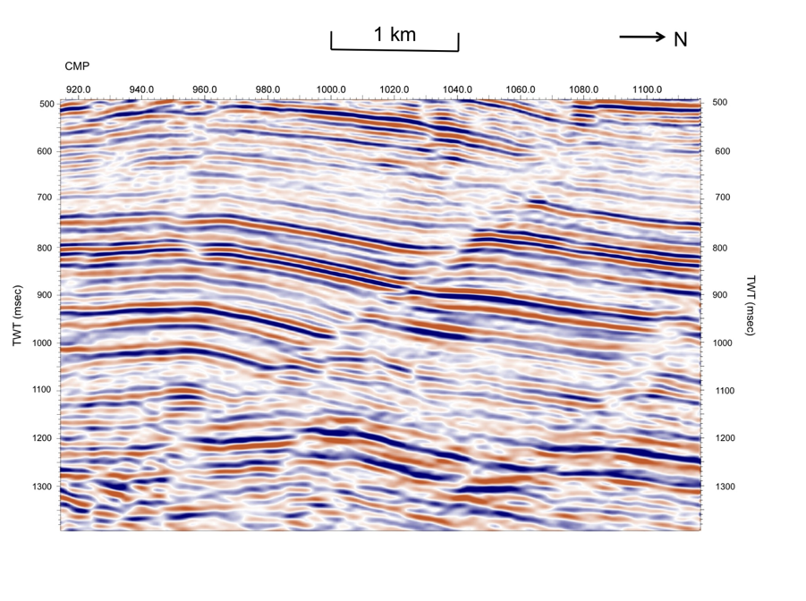
1.Use a lead pencil to mark the first horizon at CMP 980 and TWT 770msec.
2.Follow it across the seismic profile, when you are happy with your interpretation mark it with a coloured pencil.
3.Do the same for the second horizon at CMP 980 and TWT 970msec, using a different colour.
4.Draw on any faults you can see (places where the horizon is broken) in lead pencil.
5.Mark the upthrown and downthrown sides of the fault with arrows.
6. On the seismic data annotate each fault with a letter (A, B, C etc.) and for each one decide if it is normal or reverse fault. Write your answers in the table below:

Fault identifier letter | Fault type

