Name ___________________ Date________
Fault picking exercise
There are two horizons to interpret and several faults on this seismic profile. One fault has already been marked on as a black line.
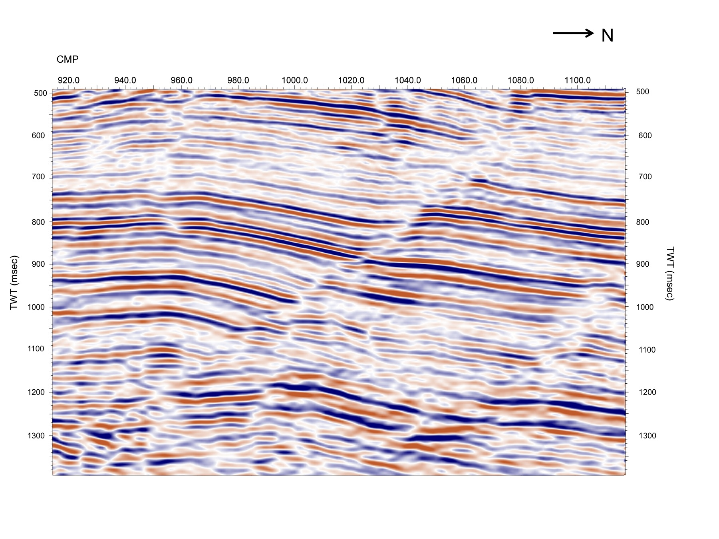
1. Use a lead pencil to mark the first horizon at CMP 980 and TWT 770msec. It is marked with a black dashed line to help you.
2. Follow it across the seismic profile, when you are happy with your interpretation mark it with a coloured pencil.
3. Do the same for the second horizon marked with a white dashed line at CMP 980 and TWT 970msec, using a different colour.
4. Mark the upthrown and downthrown sides with arrows on the fault marked in black.
5. Is it a normal or reverse fault?
6. Pick at least one other fault on the seismic profile, mark it with arrows to show the sense of movement and decide if it is normal or reverse.

