Name: __________________________ Date: _______________
Geological History exercise
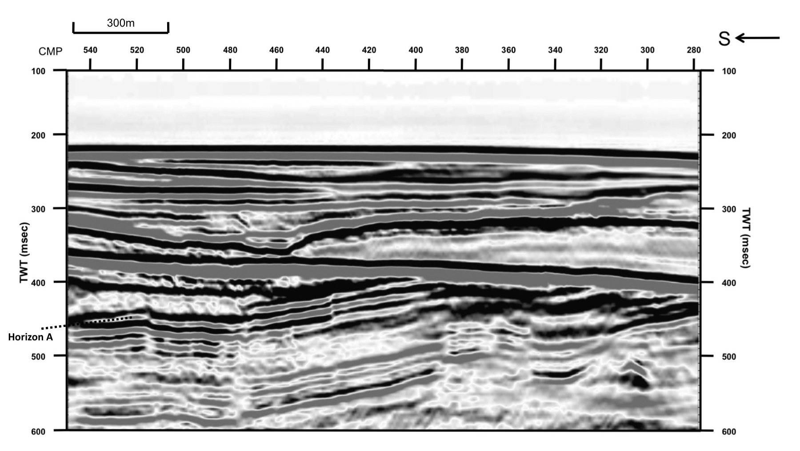
This seismic profile has horizon A identified at CMP 520 and TWT 450msec.

1. Interpret this horizon and mark on any faults with arrows to show the displacement.
2. What happens to the interpreted horizon at CMP 390?

3. What is the strong feature at around 400ms that dips gently to the north?

4. Use the law of cross-cutting relationships to put the geological events you can see into the correct order.
Geological history

