Name: __________________________ Date: _______________
Geological History exercise
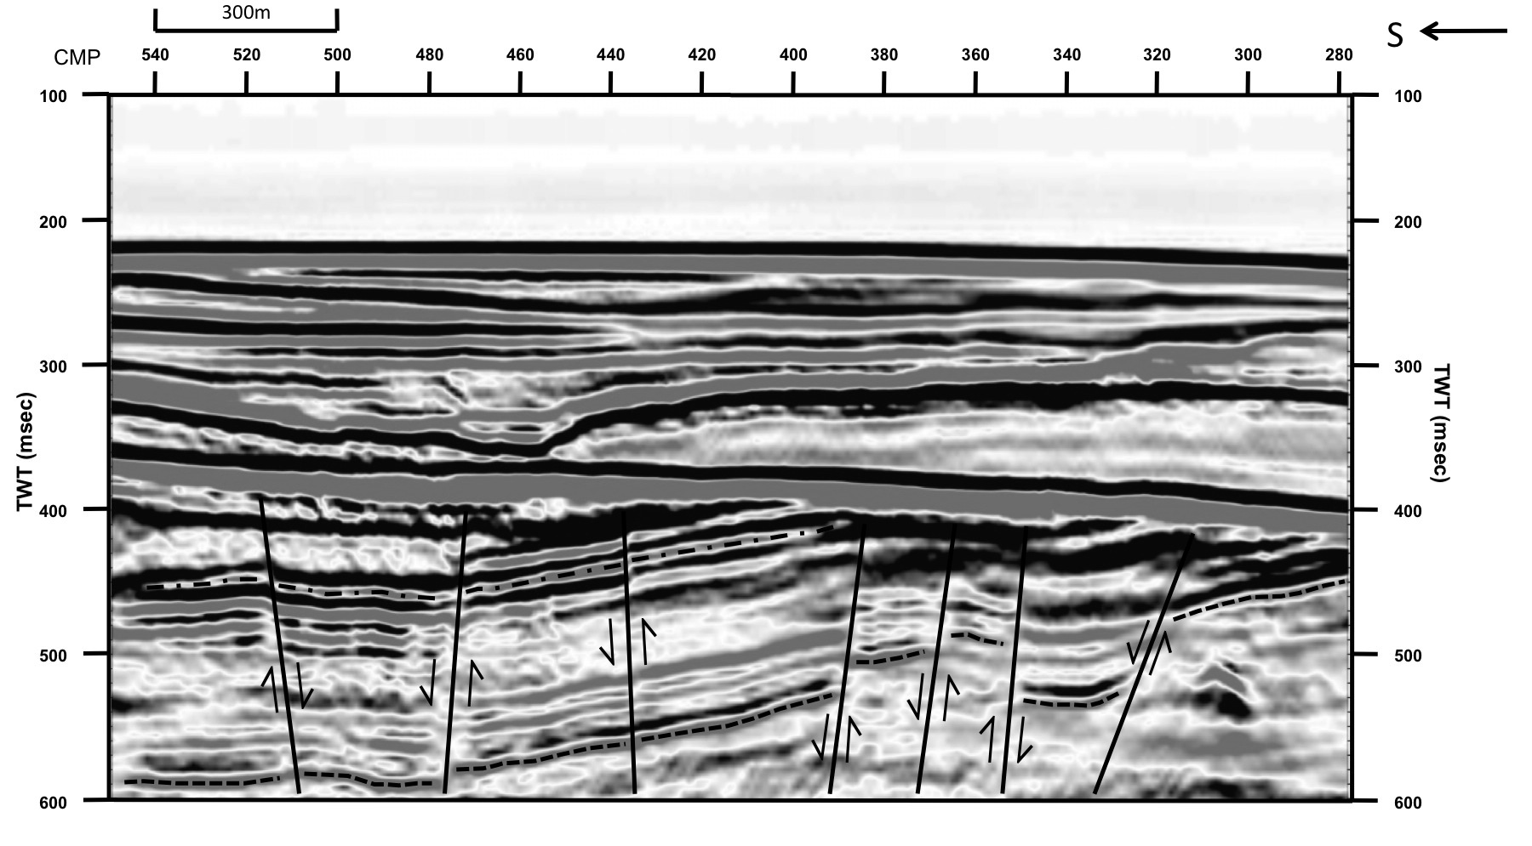
This seismic profile has two horizons and several faults marked on it.

- What is the strong feature at around 400ms that dips gently to the north?

- Use the law of cross-cutting relationships to put the geological events you can see into the correct order.

Geological history

